**WEBSITE SDLC DOCUMENTATION**

INDEX

1.Problem Statement 2

2.Solution Approach 2

2.1 Requirements 2

2.2 Analysis 2

2.3 Design 3

2.4 Development 4

2.5 Integration and Testing 4

2.6 Implementation 5

**SDLC DOCUMENTATION**

The Software Development Life Cycle (SDLC) is a process used to design, develop and test software. The SDLC aims to produce a high quality software that meets or exceeds the customers expectations, reaches completion within time and cost estimates. SDLC documentation provides us a detailed insight about the flow of work that needs to be done before actually getting started with the real development of the project. It aims to be the standard that defines all the tasks required for developing and maintaining software.

A typical software development life cycle consists of these following steps :

1. Planning and Requirement Analysis

2. Defining Requirements

3. Designing the Software Architecture

4. Developing the Software

5. Testing the Software

6. Feedback and Change

7. Deploying and Maintaining of Software

Out of the available SDLC models , this specific work uses WATERFALL model’s approach for its successful completion. The sequential phases used here are as follows :

1. Requirement gathering
2. Analysis
3. Design
4. Development
5. Integration and Testing
6. Deployment

**1.PROBLEM STATEMENT :**

To create a portfolio website which has a social theme applied in common to all the web-pages it contains and should look aesthetically appealing and responsive .

**2.SOLUTION APPROACH :**

**2.1. Requirements:**

The first stage in SDLC in which all the requirements required to be gathered for developing the website will be jotted down . The key requirements required are

1. Theme
2. Unique web-pages for my portfolio which includes home, academics, achievements, gallery, contact and a web-page to support my theme.
3. A general layout of the website.
4. A text editor to develop the website.
5. Content to be displayed on the website.
6. Repository to remotely access my work when needed.
7. Method for local hosting.
8. A platform to test the working of the website.

**2.2.Analysis:**

The requirements specified above are analyzed and it jots down to the following necessities :

1. Save The Stray Animals as a common applicable theme.

2. Visual Studio because it supports development in languages like HTML5, CSS and JQuery with builtin emmets.

2. draw.io to create wireframes of the website.

3. Images and contents for my portfolio and for the social theme page.

4. Github for source control and repository.

5. IIS Web-server for local hosting.

6. Lighthouse for testing the website.

**2.3. Design:**

1. Wire frame**which acts as a blueprint for the website is designed using draw.io and an example of it looks like** :

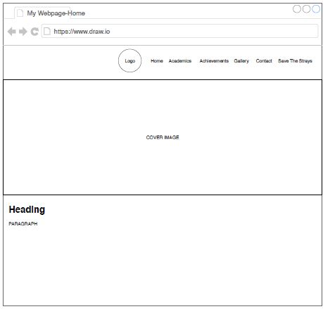

**2.4 Development :**

The actual source code will be developed in this phase based on the designed wire frame and requirement analysis. This is the phase where the actual coding starts and ends in a website . While developing the code ,best practices that suits the industrial standards are required to be followed.

1. HTML5 is used for defining the contents that needs to be included in the web-pages.
2. CSS is used to style the website contents into an attractive and appealing manner.
3. Jquery plugins are used for image slideshow in the gallery section.

**2.5** **Integration and Testing**:

In this phase the individual web-pages are integrated together with each other through means of links to form a meaningful website . The website once developed needs to be rigorously tested for errors and bugs and the feedback from these testing should be taken into account and should be rectified in the design/development process. The following tests have been carried out :

Functionality Testing:

**1.**Verified there is no dead page or invalid redirects.

2.Verified the work flow of the system.

3.Tested the functionality of links in all the pages .

Usability testing :

1. Tested the navigation and controls.

2. Content checking.

3. Ease of use.

Responsive testing :

Responsive testing is performed to check the responsiveness of the website when the browser dimensions vary and check the compatibility to various devices like tablets and mobiles.

Further the website was tested using lighthouse testing website and the scores will look like:

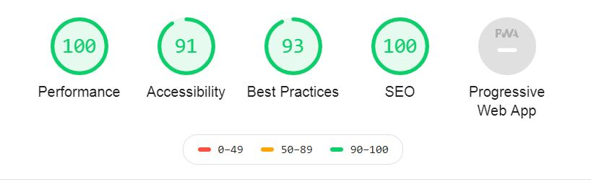

**2.6 Implementation:**

1. Once the software testing phase gets over and no bugs or errors are reported then the implementation process starts.
2. The website was locally hosted by using IIS web-server.